SIMATS ENGINEERING
ASSESSMENT TOOL1
COURSE CODE: MLA 02 COURSE NAME: Fundamentals of Machine Learning
COURSE OUTCOME COVERED
CO2: Apply supervised learning algorithms for regression, classification, and predictive modeling tasks to solve structured data problems in practical applications. (BL3)
Assessment Tool Weightage: 40%
QUESTIONS: 10 Total Marks:50 Annexure A
Analytical Problem Solving
Code of Conduct:
I SHAIK ARSHAD(192425080) (Name / Reg No) certify that this submission is my original work and that I have adhered to the guidelines specified for this assessment.
I understand that any violation of academic integrity rules will result in disciplinary action. Signature of the student:ARSHAD

Annexure A
Analytical Problem Solving
Q1.A real estate company collected the following training data:(15Marks -20 Mins) House No Area (sq.ft) Bedrooms Price (₹ Lakhs)
1 1000 2 50
2 1500 3 75
3 800 2 40
4 1200 3 60
5 2000 4 90
(i) Construct a linear regression model of the form
(ii) Estimate the regression coefficients.
(iii) Interpret the meaning of each coefficient.

CODE: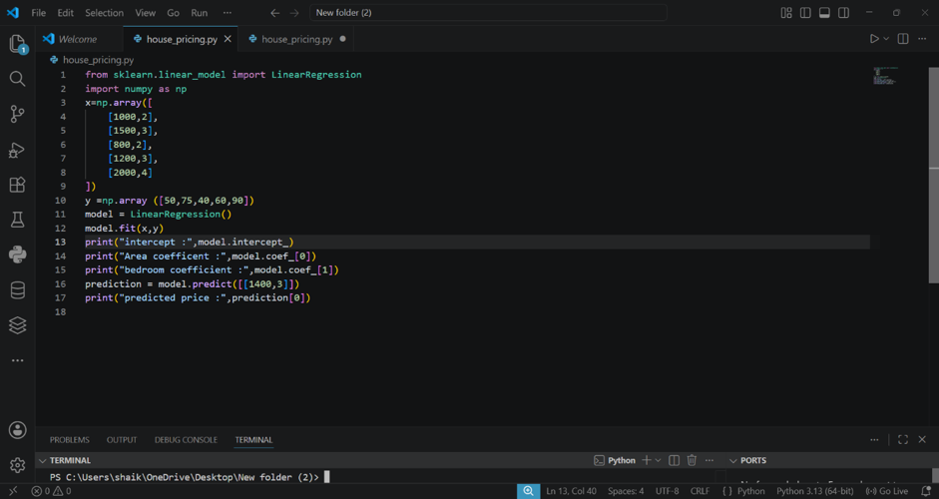
OUTPUT:
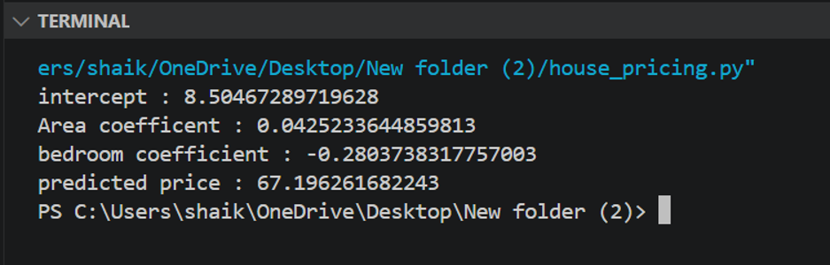
Q2.An email system uses the following feature values:(15Marks -20 Mins) Email Word Frequency (Offer) Word Frequency (Win) Spam (1/0) 1 3 2 1
2 2 1 1
3 1 0 0
4 3 3 1
5 0 1 0
(i) Construct a linear classification model.
(ii) Determine the decision boundary.
(iii) Classify a new email with: Offer = 2, Win = 1.

CODE:
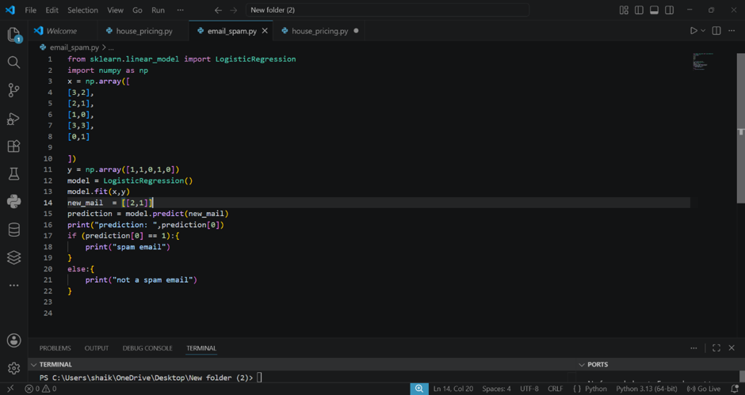
OUTPUT:

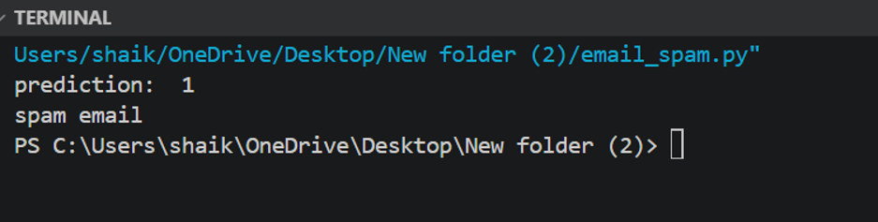

Q3.A medical dataset is given:(15Marks -20 Mins)
Patient Fever (1/0) Headache (1/0) Disease (Yes/No)
1 1 1 Yes
2 1 0 Yes
3 0 1 No
4 1 1 Yes
5 0 0 No
(i) Compute prior probabilities.
(ii) Compute conditional probabilities.
(iii) Estimate the probability that a patient with Fever = 1 and Headache = 0 has the disease.

CODE:



OUTPUT:

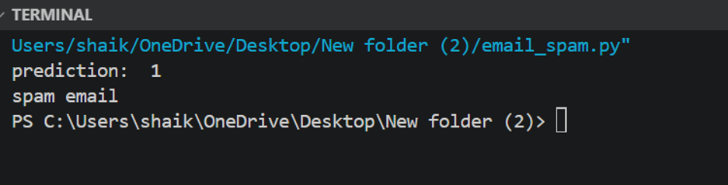

RUBRICS FOR CALCULATION
Numerical Problems
Criteria | Weightag  e | Level 4  (Exemplary) | Level 3  (Proficient) | Level 2  (Developing) | Level 1  (Beginning)
Problem  Understanding | 20% | Clearly  interprets  problem,  identifies all  parameters  and  requirements accurately | Understands  problem with  minor gaps | Partial  understanding; misses key  elements | Misinterprets or unable to  understand  problem
Method  Selection | 20% | Selects most appropriate  method/formula with strong  justification | Selects correct method with  minor errors | Inappropriate or partially correct method | Unable to  select method
Solution  Process | 25% | Logical,  systematic  steps with  correct  approach  throughout | Mostly correct steps with  minor mistakes | Disorganized  steps; multiple errors | No clear  process

Accuracy of
_{Calculation} 20%
All calculations accurate;
correct final answer
Minor
calculation errors
Frequent errors; incorrect final answer
No valid
calculations

Interpretation of Results | 15% | Clearly  interprets  results with  units and  engineering  relevance | Basic  interpretation  with minor  omissions | Limited or  unclear  interpretation | No  interpretation

